**CS 6314 Web Programming Language**

**Final Project Report**

* **Project Title:**

Hotel reservation system

* **Name for the Website:**

[Super Hotel](http://localhost:3000/index)

* **Project Description:**

This project the website of Super Hotel. On this website, users will find all information they are looking for about this hotel. On top of that, users can check availability of any rooms on and dates/nights. Users can also book the rooms through this website once they have registered as a member.

The admin of the website, i.e. Super Hotel, will make changes to the database of the inventory of their rooms according users’ reservation. The admin changes what to be showed on the website according to the inventory for each date/night.

Besides, the admin can edit the description of or delete a room base on the change of the room, e.g. the part of the feature is altered.

or the whole rooms is reconstructed to a totaling different room, so the original one should be deleted from the website. However the data of the deleted room will still be kept in the database.

* **Database Design:**

IMAGE of relationship

“Create Table” statements:

|  |
| --- |
| create table hotel(  hotel_id varchar(10) not null,  hotel_name varchar(50) not null,  hotel_instruction varchar(300) null,  address_street_number varchar(100) not null,  address_city varchar(15) not null,  address_state_province varchar(15) null,  address_country varchar(30) not null,  zipcode varchar(15) not null,  star_rating float null,  contact_name varchar(20) not null,  contact_phone varchar(20) not null,  contact_email varchar(30) not null,  primary key (hotel_id)  );  create table amenities (  amenity_id int auto_increment,  amenity varchar(25) not null,  primary key(amenity_id)  );  create table hotel_amenities(  hotel_id varchar(10) not null,  amenity_id integer  );  create table room_type (  room_id int auto_increment,  room_feature varchar(250),  room_name varchar(60),  primary key (room_id)  );  create table hotel_room (  hotel_id varchar(10) not null,  room_id int not null,  rooms_availability boolean default true,  total_num int not null,  room_price float not null,  primary key(hotel_id, room_id)  );  create table room_not_available_date (  hotel_id varchar(10) not null,  room_id int not null,  not_available_date date not null,  not_available_num int not null,  primary key(hotel_id, room_id, not_available_date)  );  create table bed(  bed_type varchar(20) not null,  capacity int not null,  primary key (bed_type)  );  create table room_bed(  room_id int not null,  number_of_beds int not null,  bed_type varchar(20) not null  );  create table photo(  photo_id int auto_increment,  photo_address varchar(100) not null,  primary key(photo_id)  );  create table room_photo(  room_id int not null,  photo_id int not null  );  create table hotel_photo(  hotel_id varchar(10) not null,  photo_id int not null  );  create table bed_photo(  bed_type varchar(20) not null,  photo_id int not null  ); |

* **Languages/frameworks used for implementation:**

Node.js

Bootstrap

JQuery

MySQL

MongoDB

* **Screenshots for main functionalities (5-6 screenshots will be sufficient)**

**Search for available room**

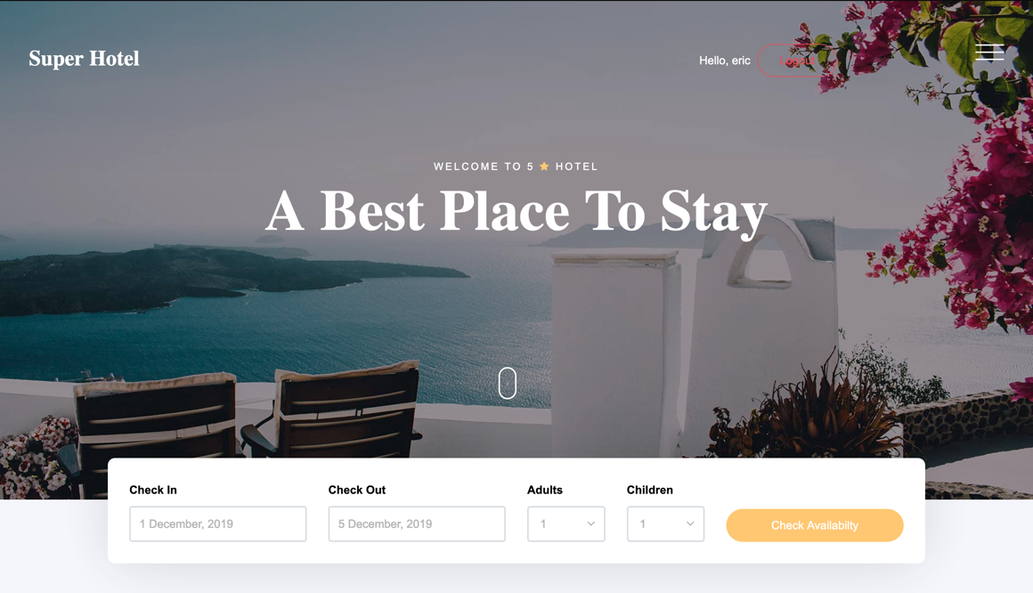

**Add/Edit a room type (Admin only)**

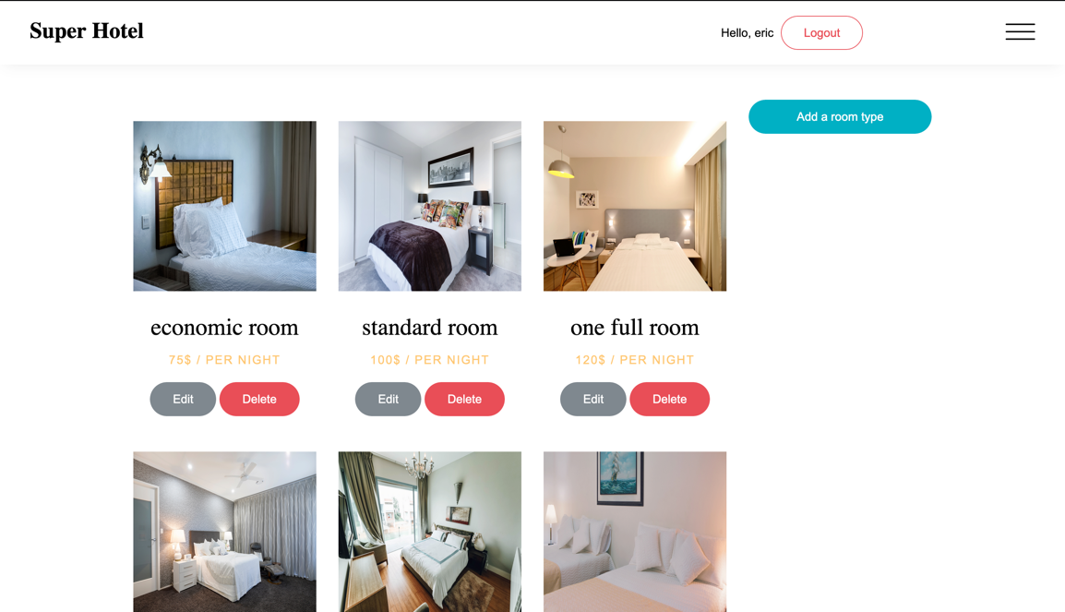

**List of all rooms for normal users**

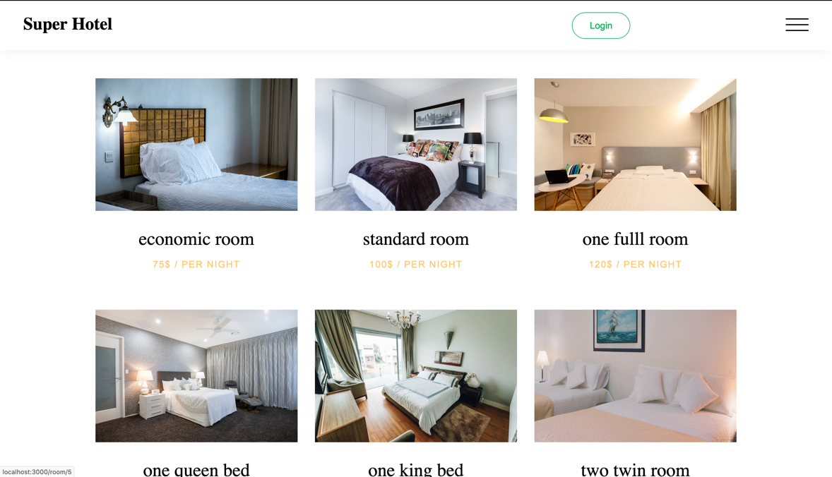

**Disable/Enable a room type (Admin only)**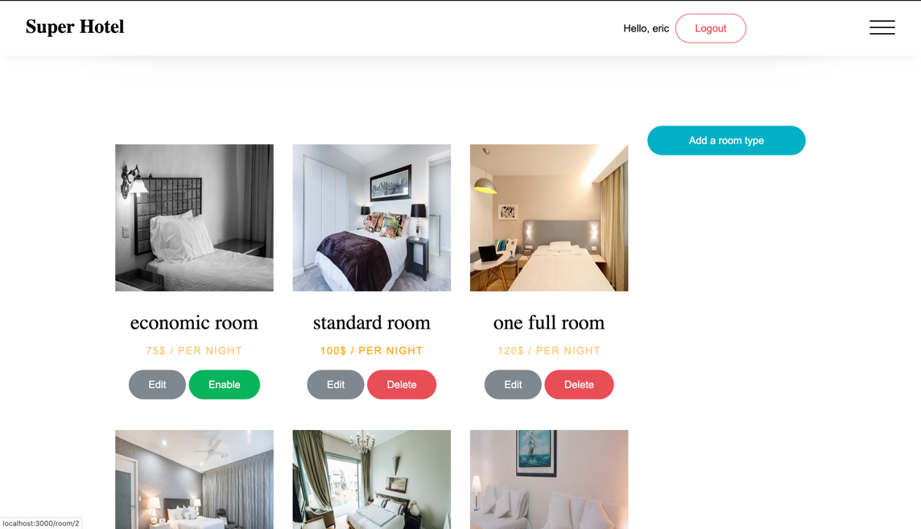

**Add a new room type (Admin only)**

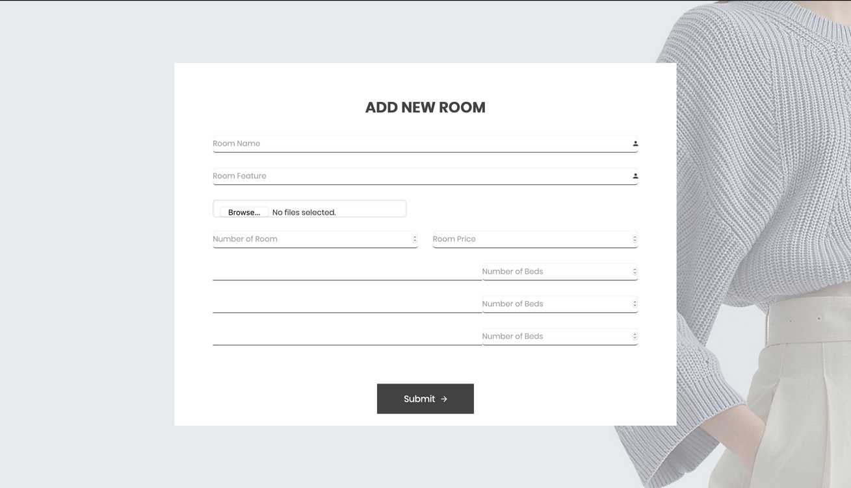

**Detect if the user input a strong password**

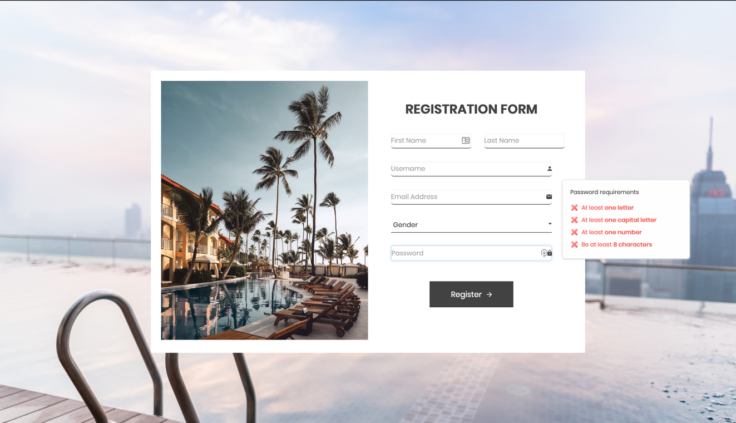

**Team Members:**

**JXL180022 – JuChen Lin**

**Yuantai Fu**

**YXC170013 – YenTing Chou**

* **Work division among team members:**
* who has completed which part (be specific and try to give page names). Please note that every team member should be actively involved in every step of the project development (database design, client-side and server side scripting) and work should be equally divided between team members.